**Influence of Others 1 (Module)**

**Module: Presence of Others**

**Subtopic: Norman Triplett**-Triplett hypothesized that the mere presence of others was an important variable in the performance of the actor  
-**Co-actor:** another individual performing the same task  
-**Audience:** a group of people watching an individual perform a task  
-**Social Facilitation:** the increased performance that occurs in the presence of co-actors or an audience

**Subtopic: A Complication  
-**Zajonc suggested that the important factor to consider is that the presence of others increases arousal  
-how heightened arousal affects performance depends on task at hand  
-for *simple tasks* for which you are an expert or well-practised, performance is *enhanced*  
-for *complex tasks*, for which you are neither expert nor well practised, performance is *hindered*

**Subtopic: Zajonc’s Resolution**-people completing simple puzzles or people well prepared for an event will perform better because the task has become relatively simple  
-a difficult puzzle or unpracticed activity will become more complex and the actor will perform worse in the presence of others  
-ex: being well prepared allows you to use the audience’s energy rather than feel anxiety and be nervous  
-if unprepared and lack confidence, pressure will tend to make you perform worse  
-ex: writing an exam when not prepared will lead to worse performance in the presence of others

**Module: Social Learning Theory**

**Subtopic: Social Learning Theory**-**Social Learning Theory:** you learn appropriate behaviours by modeling and imitating the behaviours of others (Albert Bandura)  
-social learning theory can be differentiated from basic conditioning because the behaviours you learn from others do not always require explicit reinforcement to develop

**Subtopic: The Bobo Doll  
-**an inflatable doll with a weight at the bottom that picks the doll back up once knocked over  
-individuals aged 3 to 6 were offered a variety of toys to play with in a room with an adult who was a confederate of the study adult would model either aggressive or passive play with the toys in the room  
-aggressive play mode: punching, yelling at Bobo doll, hitting it with a mallet and other toys in room  
-after viewing adult, child went into a new play room with the bobo doll and behaviour was observed  
-children who viewed aggressive behaviour were more likely to subsequently display aggressive behaviour to the doll, punching, yelling and attacking the defenseless doll  
-aggressive behaviour was spontaneous, with no explicit reinforcement or encouragement (ran counter to the pure behaviourist ideas, which would suggest that learning of a behaviour would only occur with explicit reinforcement)  
-even with a real person, children still attacked with kicks, punches and toy hammers

**Module: Conformity**

**Subtopic: Conformity  
-**it’s difficult to stand alone, which is why people decide to conform

**Subtopic: Sherif and Norm Function  
-Autokinetic effect:** we see a red light as moving when it is actually not when in a pitch black room; as your eyes scan the scene of a dot of light against a uniform dark background, you mistake the movement of the image on your retina as actual motion of the light  
-with each new day, the response of the subject increasingly converges with the two other individuals  
-after a few days of experimenting, your responses will gradually converge with the others in the experiment despite the difference starting points of the individual subjects (**Norm Formation)  
-**confederate’s response is set very high with the three subjects increasingly converge towards the confederate’s response  
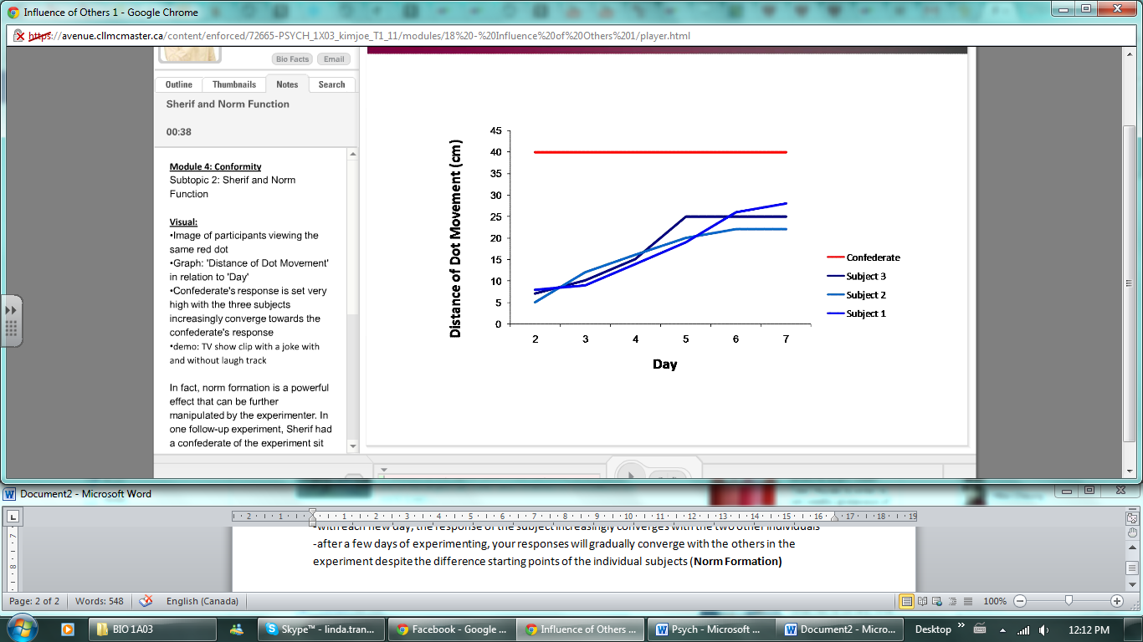

**Subtopic: Asch’s Stimuli**-subjects were seated in a room with a group of other individuals and told they were going to complete a rather simples experiment  
-they would see one sample line and three comparison lines and they would have to identify which of the comparison lines matches the standard  
-only one person is the real subject and the rest are confederates; the subject always replies sixth, with most confederates responding first  
-37% of all responses conformed to a clearly incorrect answer, and 75% of subjects conformed to an incorrect answer on at least one trial

**Subtopic: Normative Function  
-Normative Function:** the role of others in setting standards for our conduct based on a fear of rejection and ostracism (fashion trends and popular culture)  
-particularly evident in the standards of acceptable elevator etiquette

**Subtopic: Comparative Function**-**Comparative Function:** the role of others in providing information about an ambiguous situation  
-comparative function of the group provides information about reality in an ambiguous situation (fire alarm: drill or real?)  
-subject conformed to the group answer primarily because he thought the others just might be right, and he doubted his own perceptions

**Subtopic: Conclusion**-behaviour is greatly influences by both the normative and comparative functions because of social pressure and the fear of rejection and through the comparative function by providing group information in an uncertain situation

**Module: Group Dynamics**

**Subtopic: Decision Making  
-**what effect does a group have on decision making and consensus

**Subtopic: The Risky Shift**-groups were more cautious than individuals  
-asked individuals to read a set of hypothetical situations and make risk assessments  
-individuals then came together into groups to come to a consensus  
-on average, the group decisions were riskier than the mean decision of the individuals before the group discussion  
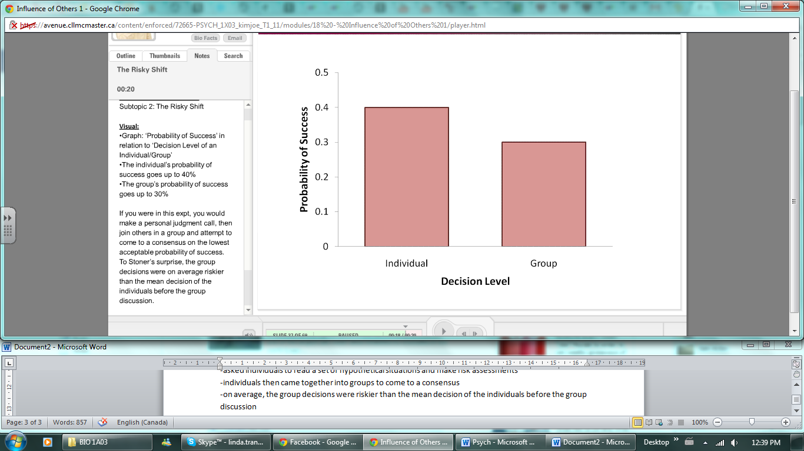  
-not every experiment produced a risky shift; in some cases the group’s decision was more cautious than the mean of the individual decisions   
-ex: Roger is a married man with 2 young children and a secure but low paying job. Roger can afford life’s necessities, but few of its luxuries. He hears of a stock of a relatively unknown company that may soon triple in value. To invest in the company, Roger is considering selling his life insurance policy

**Subtopic: Group Polarization  
-Group Polarization:** group decision making strengthens the original inclinations of the individual group members (decision making in a group tends to lead to more extreme views by strengthening the original inclinations of the individual group members)  
-this can move the group decision either in the risky or cautious extreme  
-group decision making is more complex than individual decision making  
-Helen’s level of risk is moderately high as an individual and shifts higher when in a group  
-individually, members started with a risky position, leading to a group decision of even more risky  
-Roger’s level of risk is moderately low as an individual and shifts lower when in a group  
-members started without much risk, leading to a consensus of very low risk  
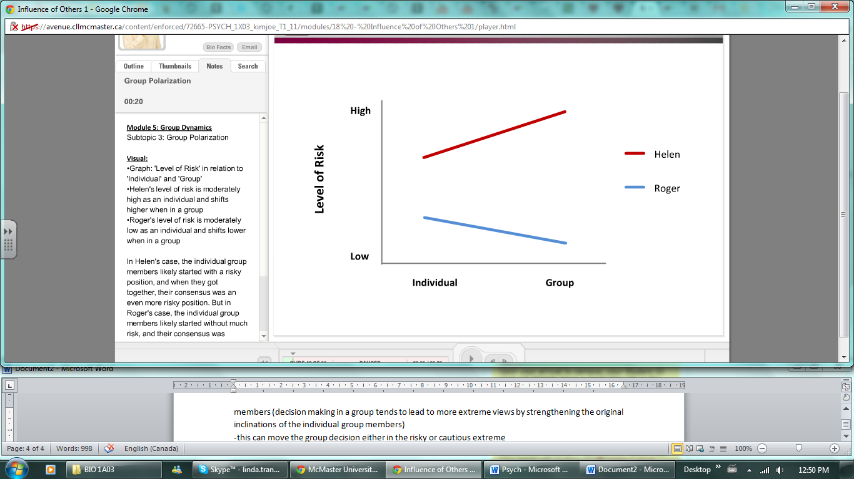  
-supported by a number of experiments which demonstrate that group decision making seems to enhance national pride, negative racial and financial attitudes and decision-making in juries  
-naturally, finding groups that share your views and encourages them can have positive or negative effects depending on the starting views of the individuals

**Subtopic: Groupthink  
-**what happens when group polarization leads a group astray?  
-**Groupthink:** a group decision making environment that occurs when group cohesiveness becomes so strong it overrides realistic appraisals of reality and alternative opinions, aka “mob mentality”  
-groups falling victim to groupthink often believe that they are unquestionably right and all other groups are wrong  
-fail to critically test, analyze and evaluate the ideas of the group decisions tend to be rationalized and pressure to conform is high  
-individuals in these groups often censor dissenting opinions and those who disagree are rejected from the group  
-Preventing Groupthink:  
 -be impartial (groups leader should never endorse any particular position from the outset  
 -encourage critical evaluation (allow group members to disagree)Devil’s advocate, divide group  
 -second chance meeting (meeting to air lingering doubts)

**Module: Bystander Effect**

**Subtopic: Kitty Genovese  
-**KG was murdered outside her apartment; she was stabbed repeatedly and that lasted for 30 minutes  
-witnesses (38) did nothing when they were fully aware of what was going on  
-witnesses were afraid of person injury if they stepped in and because there were so many witnesses, they assumed that one of the others had already called the police  
-the very presence of so many witnesses was in part responsible for the lack of action by any one of them

**Subtopic: Two Decisions  
-**before taking action, two key decisions must take place before an individual acts  
-first, an individual must decide if the situation is a real emergency and then whether the situation requires them to personally respond  
-if yes, the individual will respond, but if not, the individual will take no action  
 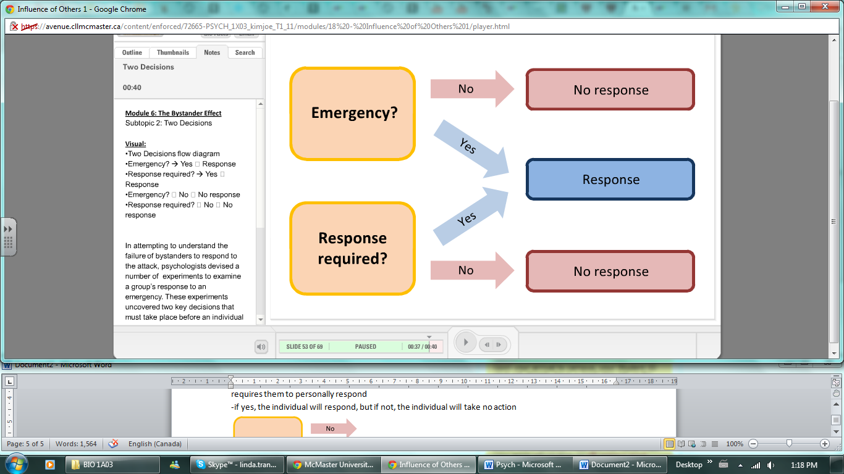  
-experiment: subjects were asked to complete a short survey in a room either alone or with a group and smoke was slowly seeped into the room, individuals reported the smoke must faster, whereas group reporting of the smoke decreased greatly  
-**Collective Ignorance**: when each individual in a group see nobody responding in a given situation, they conclude that the situation is not an emergency  
-experiment: individual is in a separate room from others and is having conversation over an intercom, one person claims that they are prone to seizures  
-during the call, the person calls for help because of a sudden seizure and individuals who believed they were the only other person on the intercom called for help and took action immediately but if the individual believed there were others on the line, their probability of taking action decreased  
-**Diffusion of Responsibility:** in deciding whether we have to act, we determine that someone else in the  
group is more qualified  
-look to see others that are also present and examine what skills they may have; particularly anyone with special skills will prevent you from acting

**Subtopic: Getting Help  
-**be direct if you need help  
-choose an individual out of the crows and give them the responsibility; this will break both collective ignorance and diffusion of responsibility for that individual  
-finding suggests that seeing someone else helping increases the probability that you will help in a later situation; helping behaviour is contagious

**Subtopic: Social Loafing  
-Social Loafing:** individuals seem to be less motivated when working in a group than when working alone  
-ex: tug of war; individuals pulled 18% less when they thought they were pulling in a group as compared to pulling alone  
-participants were told that they would be entering a room and shouting/clapping together with a group but were actually alone  
-less noise was produces if the perceived group was louder but the individual self-reported that they made the same amount of noise